**PROJECT DESCRIPTION**

**PROJECT NAME**:INFORMATION PORTAL

This webpage consists of 6 different pages:

1. Home

2. About Us

3. Contact Us

4. Login

5. Feedback

6. Registration

**HOME:**

The home shows basic information.

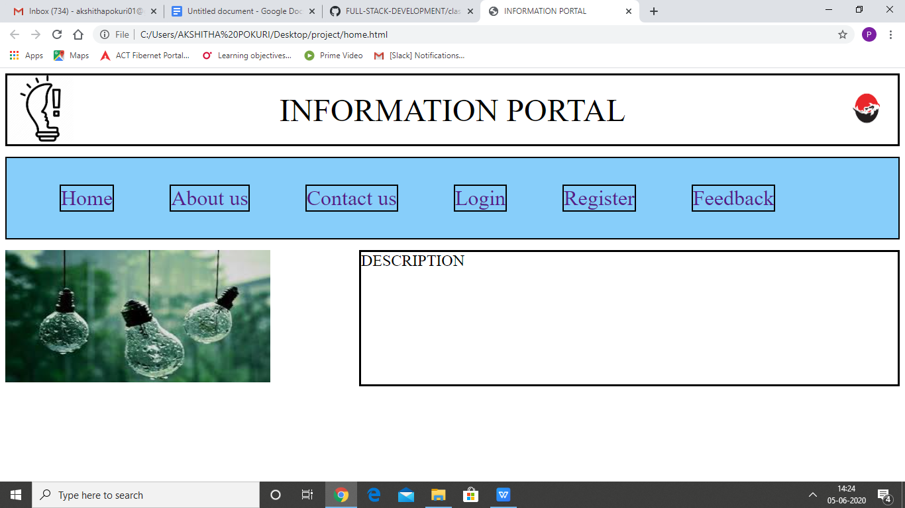

**ABOUT US:**

I have put this page basic and blank.

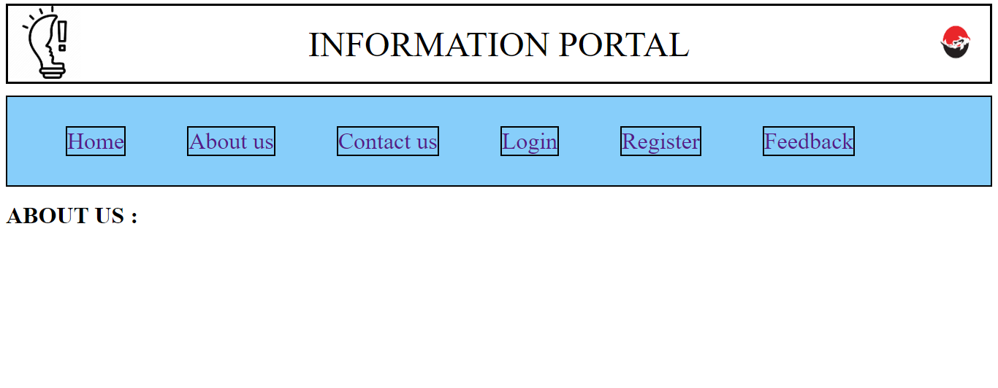

**CONTACT US:**

I have put this page basic and blank.

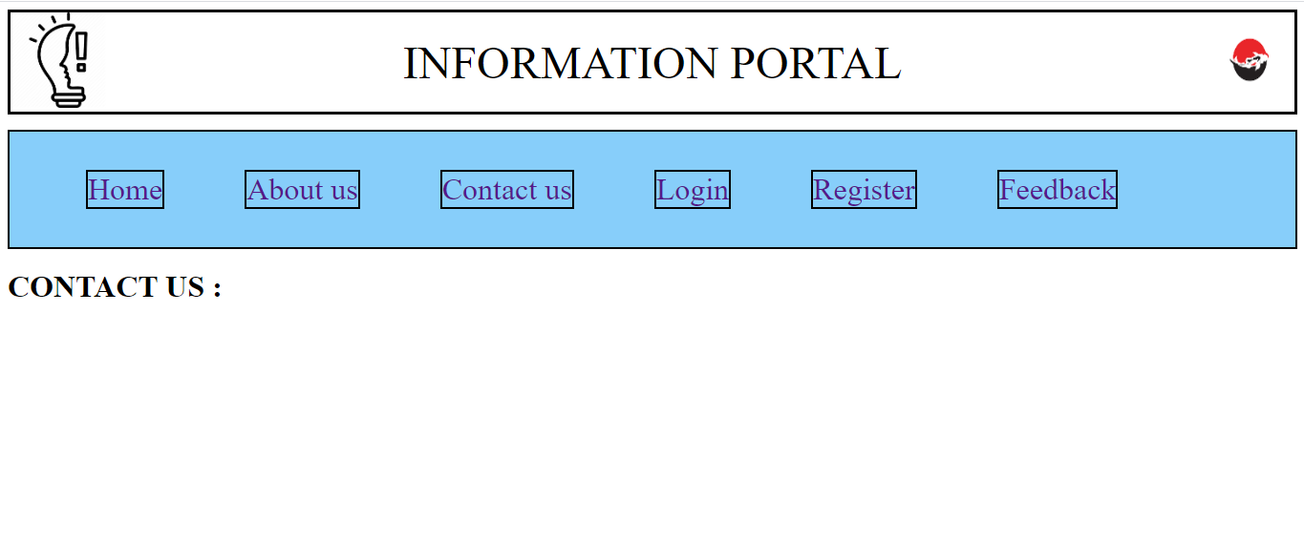

**LOGIN**:

This page is for the members who already have an account . Here java script is used to validate username and password.

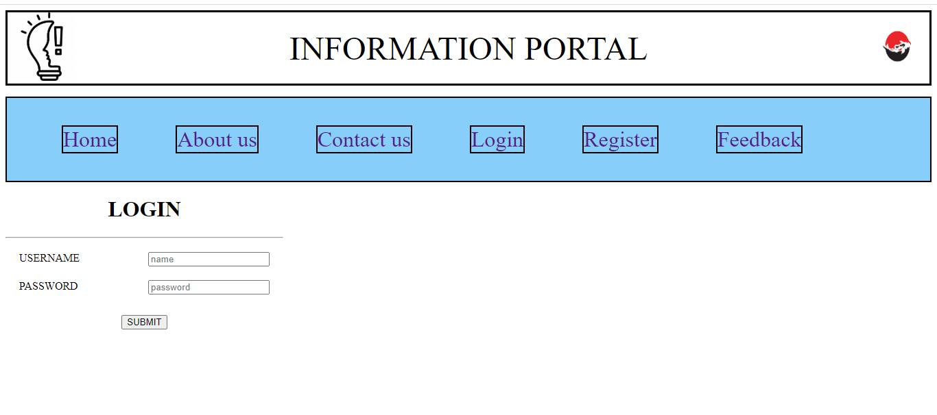

**REGISTER:**

This page is used to collect the details of the candidates who are willing to join the course.

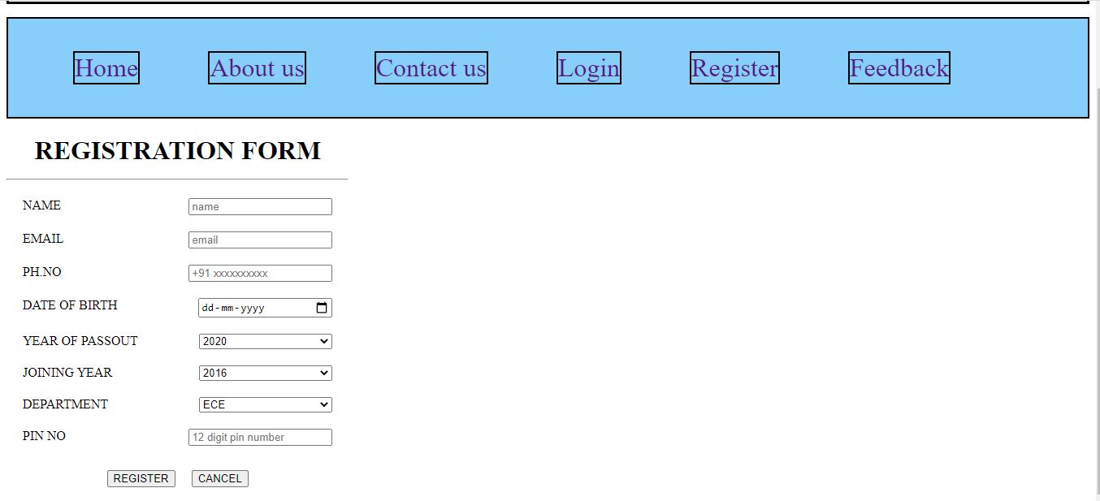

**FEEDBACK:**

After providing or at the time of providing the course each and every individual are encouraged to give feedback on the quality of service provided by us to them.

This feedback helps to rate our self and also improve the standard of services provided by us.

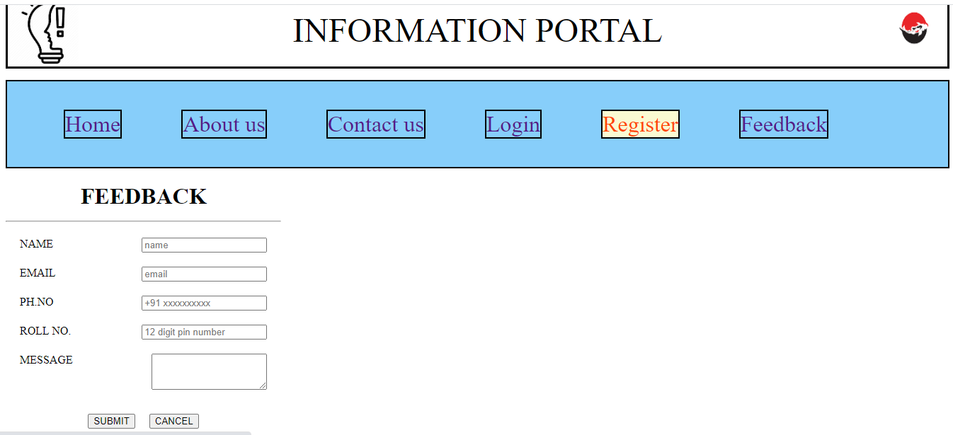

THANK YOU